Lifecare Infertility – IVF Clinic Experience

Can Tuberculosis cause Recurrent Miscarriages (RM)…….. Yes

The evidence for a role of infection in recurrent early miscarriages is weak. Any severe infection that leads to becteremia or viremia can cause an early sporadic miscarriage. However “for an infective agent to be implicated in the etiology of repeated early pregnancy losses, it must persist in the genital tract and avoid detection or cause insufficient symptoms to disturb the women”.

A recent study has reported that positive immunoglobulinG (IgG) serology for Chlamydia trachomatis is associated with early miscarriages. The authors suggest that even in the absence of a detectable organism, previous Chlamydia infection increases the miscarriage risk probably by triggering chronic inflammation. Probably the same mechanism happens with Tuberculosis (TB) as well.

Tuberculosis is number three killer of women in India in 2013. We all know that active tuberculosis contributes to only less then 10% - 30% & latent tuberculosis to 70% - 90% of cases, which is a persistent infection & remains largely asymptomatic. It is this Latent Genital tuberculosis which contributes significantly to Infertility, Recurrent Early Miscarriages; Heavy & very scanty Menstrual Bleeding; and even postmenopausal bleeding in India. However in majority of cases, latent TB remains untreated as it is difficult to diagnose due to lack of good diagnostic tests for latent Tuberculosis in virtually symptomless patients.

We all know that Tuberculosis is not the problem of the western world. So western world researchers are silent about its causative role in Infertility & Recurrent Miscarriages (RM). Indian clinicians have no time, inclination & training to do basic research, but large clinical evidence which works wonders on their patients of RM must be shared with colleagues.

Our Experience with ESR, Histopathology of Endometrial & tubal tissues, rapid culture for AFB & Xray chest was poor in picking up latent TB. Mx Test was positive in over 50% cases only. Trasvaginal sonography findings definitely gave us clue & thus helped us to aggressively motivate patients for additional tests to confirm Genital TB.

Since 2006, MycoTMA (USFDA approved test based on rRNA) , Interferon Gama Test & MTBC (a histochemistry based test patented by Dr. Ghosh of Delhi University) are used by us liberally to pick up latent TB. In MTBC, potent monoclonal antibody is tagged to MTB complex. Sensitivity & specificity of both Myco TMA & MTBC are very high for Mycobacterium tuberculosis & thus help to pickup latent Genital TB cases causing Infertility & RM readily.

Our experience of 500 cases of Primary and secondary Infertility was shared in AOGD annual conference in 2008 with Positively rate of TB was 26%. We updated our data in 2013 June of 1440 infertility cases, which shows that overall Genital TB incidence has increased to 36% at Lifecare Infertility – IVF Clinic

In Addition we have found that TNFa , a cell mediated Immune marker (Th I )is also raised significantly in genital TB. It seems, two together play a disastrous role in pregnancy failure. In other words this suggests that RM and infertility may be secondary to presence of these two factors. In 90% cases both were positive i.e. TB & TNFa. ; in 4-5 % cases one is positive and other was negative & viceversa.

Since 2003, Lifecare Centre, a superspeciality Gynae clinic runs a dedicated Recurrent Pregnancy Loss Clinic. Roughly we see 80-100 cases per year. Our experience tha Genital TB is one of the main causes of RM in India was presented at National Conference on Genital Koch’s 2010 and in many dedicated workshops on recurrent miscarriages in Delhi / NCR & Northern India in last Four years .
Recent update of 680 cases in June 2013, gives the Incidence of TB in Recurrent Miscarriages as 39%, which we shared again at Annual Conference of AOGD 2013 (Sept) & in different forums of Delhi Gynaecologist Forum.

The huge success of ours in managing RM cases is due to our change in attitude & flexibility to detect latent Genital TB in cases tipped by ultrasound, Montoux Test & ESR. & then confirmed by MycoTMA or MTBC & Interferon gamma tests (TB Gold Test). Positive tests did justifyanti tuberculous treatment for 6 months.

In our experience, majority of patients who do get pregnant do so spontaneously within 3-4 months of staring ATT treatment. Those who do not conceive generally have poor pregnancy rates with COH & IUI and need IVF /ICSI.

When we analyzed pregnancy outcome of RM in last 10 years , nearly 35% pregnancies were complicated by early IUGR & decreased amniotic fluid, needing aspirin and low molecular weight heparin. Special credits is given to the support of Tertiary Level Care Nursery, which could save almost all preterm babies of over 900 grams in our practice.

Unfortunately, the majority of Indian doctors like us can’t explain the exact role of altered cellular immunity in latent genital TB infection. But it is not uncommon to find raised TNFa in positive Genital TB cases .We have formed a definitive recommendations for the screening for latent TB in RM & Infertility Cases. & if positive to give ATT treatment for 6 months to get good pregnancy outcome.

The existence of Latent TB &Raised TNF in large number of infertility & RM cases do suggest an important but detrimental role played by two together in patients immune system & her fertility potential. It is heartening that hundreds of other gynaecologists too have similar findings to share now in RM cases in Delhi /NCR & thus strengthening our screening & management model for patient with Infertility & RM.

Conclusions:
- Latent Genital TB contributes significantly to Infertility and Recurrent early Miscarriages
- Suspicion raising Tests are Moutoux test & Transvaginal Sonography.
- Latent Genital TB is diagnosed by MTBC test, Interferon gamma test, Myco TMA. (USFDA approved test based on rRNA)
- TB if treated, gives very satisfying success rates in Recurrent Miscarriages pregnancy outcome.
- But Cure starts with Detection. It is time for you to screen for latent Genital TB in RM
Cases & get same results as we have got.
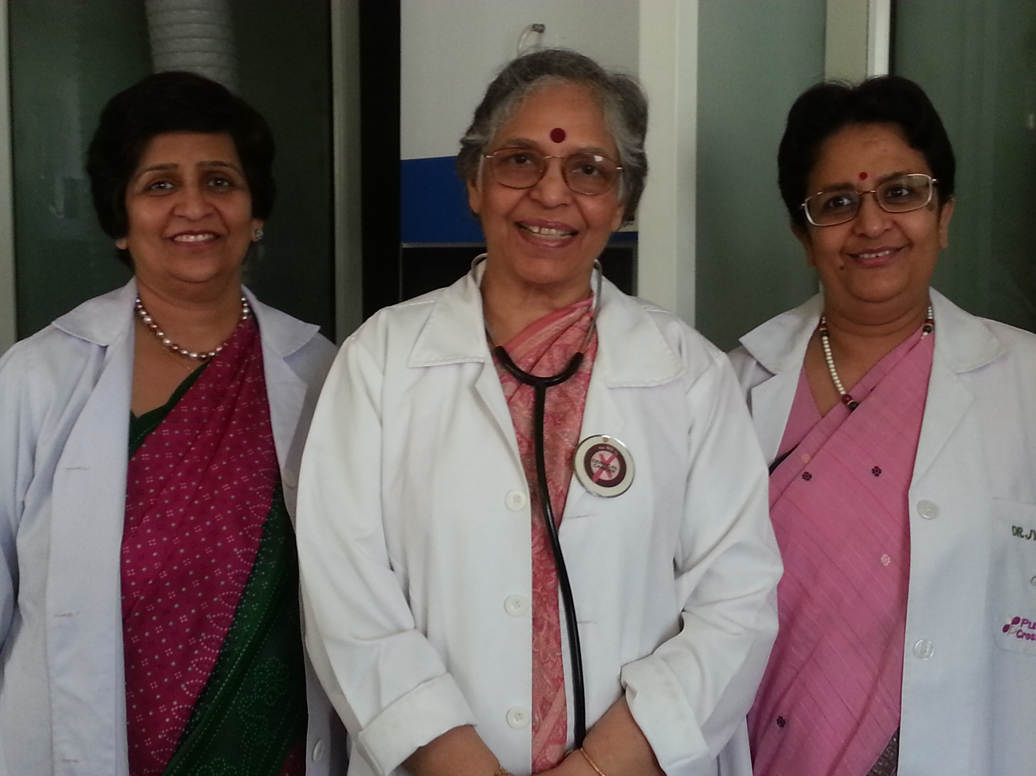

Dr. Sharda Jain
Prog Director Lifecare IVF

Dr. Jyoti Agarwal / Dr. Jyoti Bhaskar
Directors, lifecare IVF

